1. **Agenda**: As far as intrinsic (monitor) lock is concern, is it possible to make communication b/w two threads.
2. 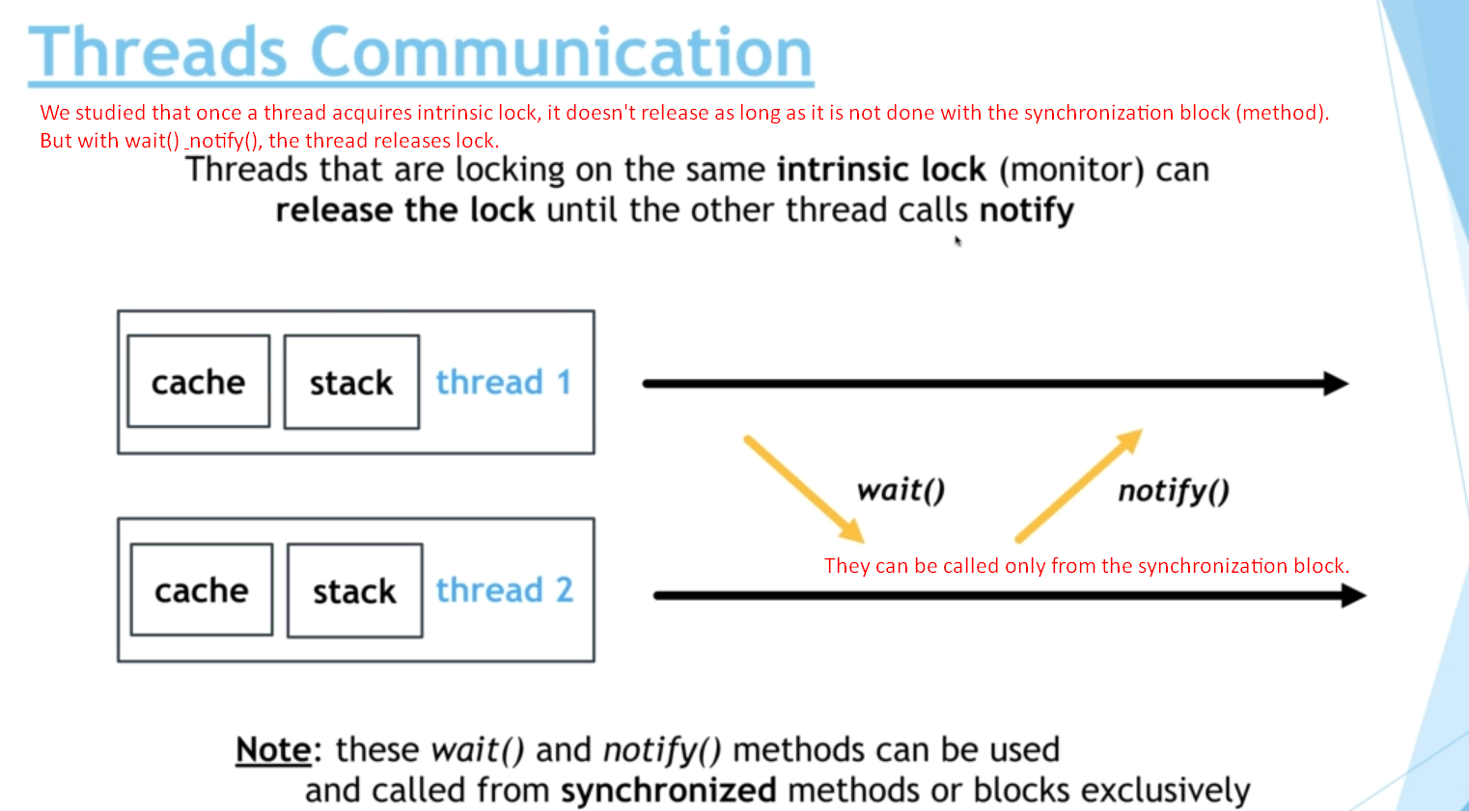
3. 